Serial Number: D9LLLYKO1LNA

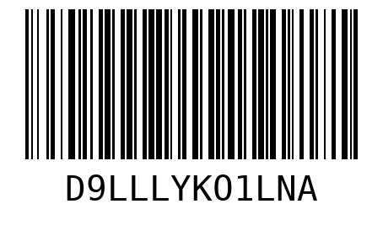

Serial Number: TOQG9O40LNXH

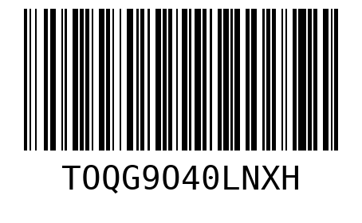

Serial Number: JFTS1FRYD5WL

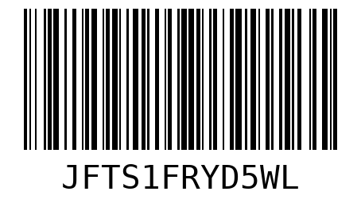

Serial Number: FWS6US4JJ5IJ

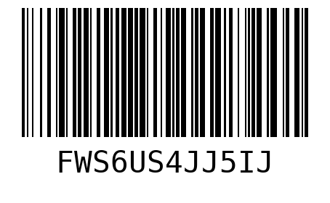

Serial Number: L697EBL0BJYR

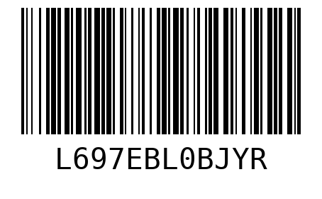

Serial Number: 9HN4USCAPZAR

